## **IZMIR UNIVERSITY OF ECONOMICS**

## **FACULTY OF ENGINEERING**

## **SOFTWARE ENGINEERING**

**FENG 498 PROJECT REPORT**



Kill Bill

Author(s): Barış Erenler

Kerem Can Özcan

Mehmet Algül

Metin Akın

Utku Aksakallı

Supervisor: Senem Kumova Metin

**OUTLINE**

Title page

Table of Contents

1. Abstract
2. Introduction
3. Literature Review
4. Methodology
5. System Requirements
6. System Design
7. Results and Discussion (if applicable)
8. Conclusion
9. References

**1. Abstract**

In our project which called Kill Bill, we actually worked in two different parts for this project. These parts are the Raspberry Pi and mobile application. In the Raspberry Pi part, we have done with the taking photos from the different and relevant meters, and we processed the photos and we took the numbers from the meters. After that part, in the mobile application, we took these values from our database and calculated the real bill.

Our biggest motivation is to help people who want to do not worry about overpaid bills. So we want to do that in the smart home system sector in this world.

The methods that we used in this project is Agile Software Development. Because it is important to have individual and interactions over processes and tool, working software over comprehensive documentation, and responding to change over following a plan.

* What results did you get?
* What do your results mean?

**2. Introduction**

Kill Bill has an objective of people can access to the water and electricity meters’ information at any certain time and it helps people learn their bill cost. This system supports people to learn billing fees instantly and usage information of their own. One of the important economic problem for households, industrial companies, public institutions is the real value of the cost of bills. Therefore, with the regular increases in bill costs, people may face unexpected prices at the end of the month. Kill Bill is a software project that is divided into two in itself; Raspberry Pi and the mobile application part. Raspberry Pi part is responsible for taking photos from the relevant meters and processing values for the mobile application usage. Mobile application part related to the taking values from the Raspberry Pi system and gives the calculated bill to the end users. These are the two different processes, but they work for the same project that is called Kill Bill.

**2.1. Problem Statement**

Most of the applications of today that are for calculating bills are already exists, but none of them are processing the meter image and calculating the current bill. In addition to that, there are no existing systems that combine the two ideas together.

**2.2. Motivation**

Our project is a type of project that is a solution for the physical paper bills and its unexpected prices at the end of the month. People can may face with a different bill costs and it can be a hard to pay them wrong bill costs. So our project helps to the people in that problem. In its particular field, people can see their bills on paper bills and they can not see their bill costs whenever they want to. Kill Bill is a nature-friendly project and it gives a chance to people know their daily usages in their electricity and water meters.

**3. Literature Review**

Here is the literature review that we found and researched about the application in the world. These types of applications has some advantages and disadvantages over the Kill Bill. So, we have mentioned that differences in the applications. The applications are the “MAHAVITARAN”, “PAYTM”, “PhonePe”, and “Fatura Sorgulama ve Ödeme”.

**MAHAVITARAN**

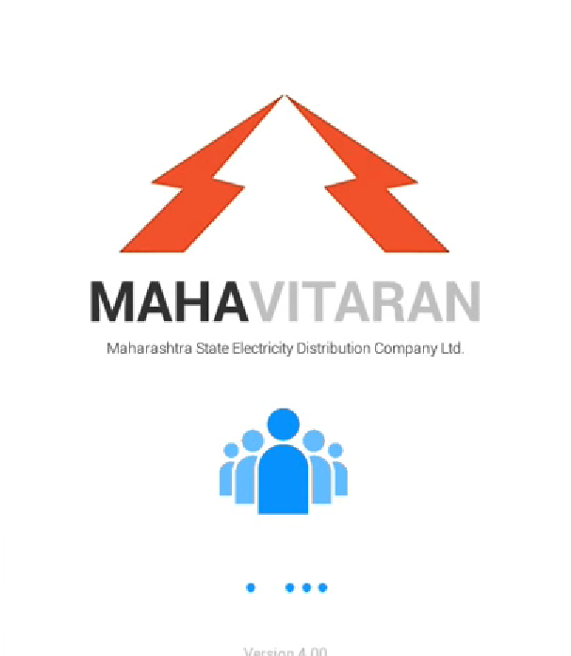

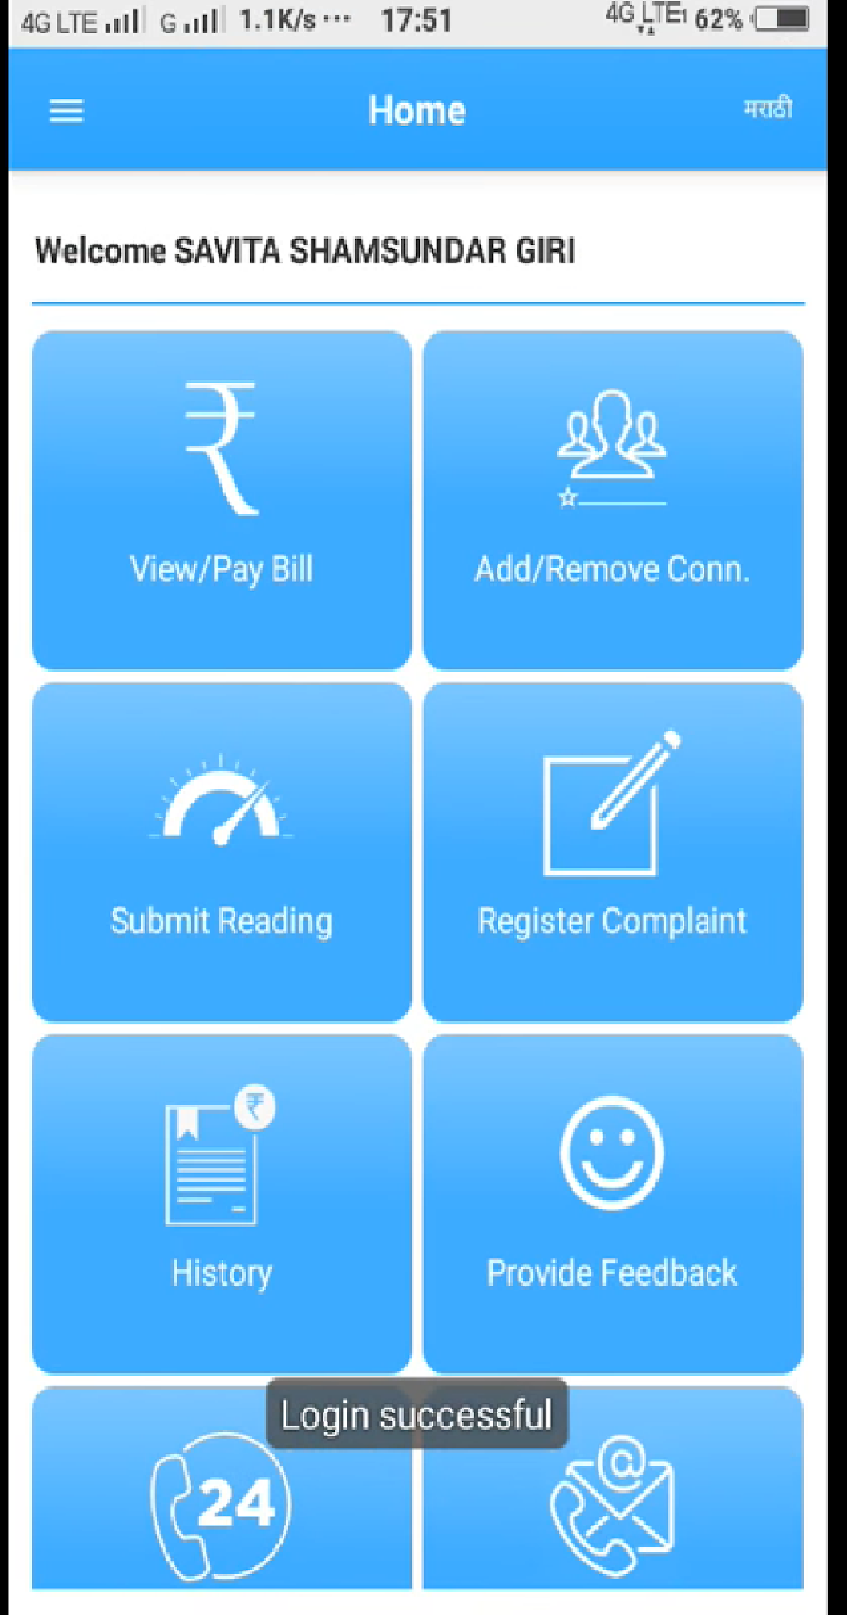

This electricity company is in Mumbai/India.Mahavitaran has its own application. Sends bill information with its own infrastructure control without using arduino camera .

**PAYTM**

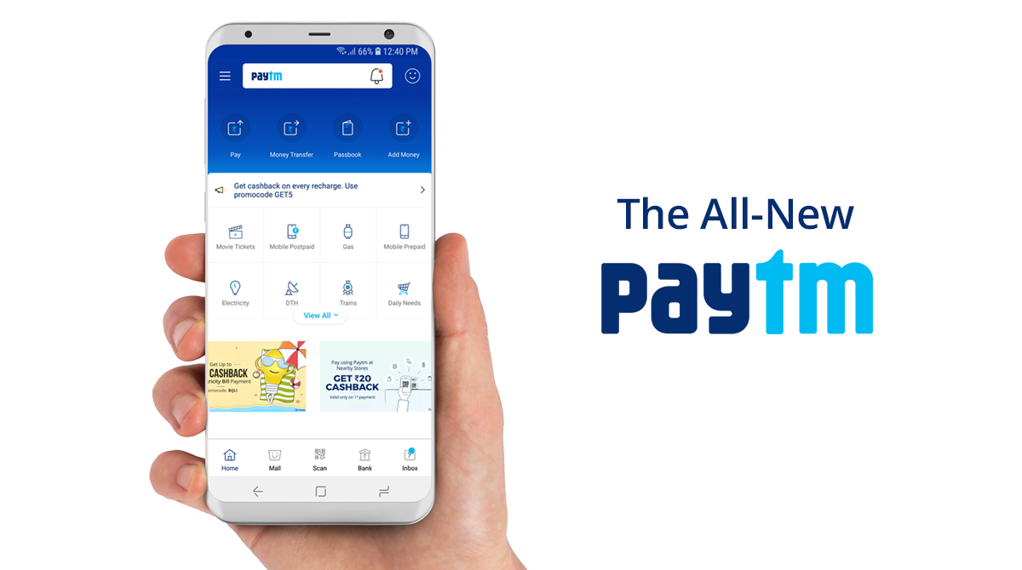

Paytm introduce a new facility which allows you to pay your electricity bill online. The online bill payment facility of Paytm. By using the specialized and superior option.

**PhonePe**

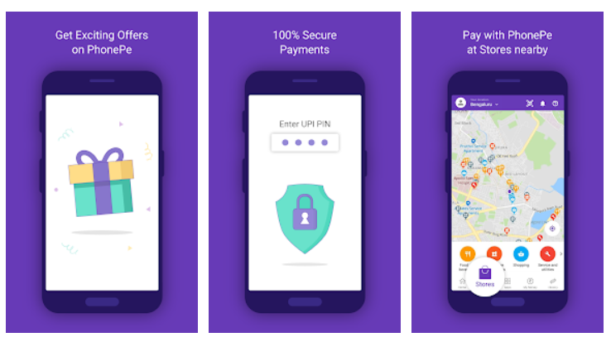

PhonePe is a revolutionary way to make mobile payments in India. From UPI payments to recharges, money transfers to online bill payments.

**Fatura Sorgulama ve Ödeme**

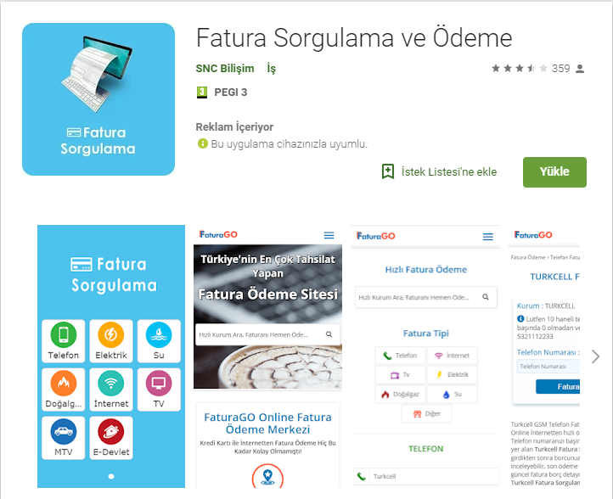

Fatura Sorgulama ve Ödeme is way to see their monthly bills and payment application in Turkey. Actually, it is using some API’s to have relevant information of the user bill cost.

**4. Methodology**

Before the development of our project, we have determined the problem to solve by developing this project. We have decided to build these bill cost calculation system by seperating the project as two parts which are mobil application and Raspberry Pi 3 device system. As our development plan, half of our developer team have developed a Android mobile application which can be used by users to reach bill informations. Otherwise, other team members have developed the Raspberry Pi 3 system. Rspberry Pi 3 device has programmed for taking pictures and send them to SQL Database. Users can reach the information on these pictures by using the mobile application, so we have developed 2 sided project for usage of these system.

**5. System Requirements**

**5.1 Registration**

* User must choose the “Register” button if he/she doesn’t exist in the system as user.
* User must complete registration into the system with these informations; full name, username, email, phone number and password.
* User must check the informations and verify the registration by using “Complete Registration.
* User registration informations are sent to the database by Registration Activity and stored.

**5.2 Sign-In**

* User must fill the “Email” and “Password” fields to access the system.
* User informations are compared with the informations about current user in database.
* If the informations which are taken from the user are correct, user can be authenticated and access the “meter menu” activity.
* If the informations are incorrect, sign-in request is denied.
* Raspberry Pi 3 device is triggered and takes photo of the meter for the first time. If user have more than device for different services, these devices are also triggered at the same time.
* These informations are taken from meters by image processes and stored in database.

**5.3 Gathering Bill Informations**

* User faces the main screen at the beginning of the system.
* User can choose the services from electricity, natural gas and water to receive bill information as price.
* Raspberry Pi 3 device is triggered by the mobile application according to user’s choices. If user chooses the electricity, Raspberry Pi 3 device which is located to see the electricity meter is triggered.
* Raspberry Pi 3 device takes photo of the selected meter and take the numbers on the meter by using image processing.
* These numbers are processed as a string values.
* These value is calculated by calculation function according to the first value which is taken from database.
* The calculation result is displayed by the application to the user.
* If user wants to access the informations of the more than one service, he/she can track the same steps for each services.

**5.4 Gathering Detailed Information**

* User can also select the “Details” from the menu bar on the left of the main screen and select the services again.
* User can access old billing information records and usage analysis which are shown as graphically grouped by services.

**5.5 Device Identification**

* User must identify the Raspberry Pi 3 device ID to the mobile application to connect the device which takes photo of the meter.
* User can also identify the new devices or update the device id by using “device identification”.

**5.6 Sign Out**

* User can select the “sign out” from the menu bar again,
* If user select the “sign out”, he/she exists from the system and faces with the opening screen.

**6. System Design**

**6.1 Context Models**

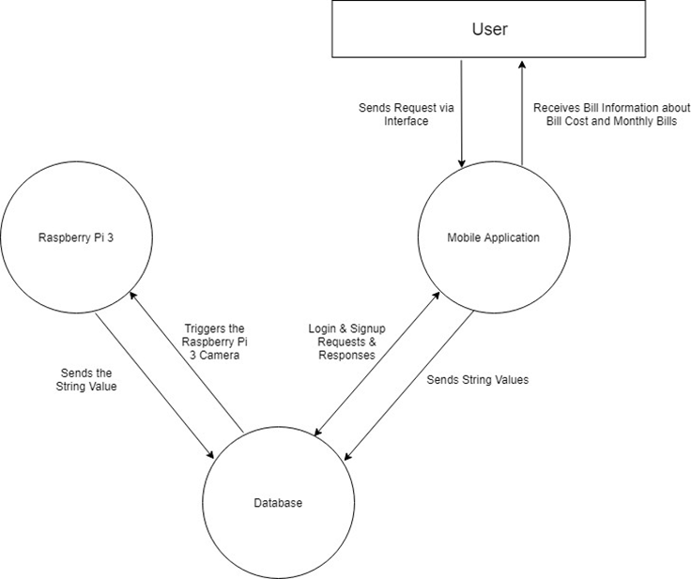

Figure 6.1 - Context Model

**6.2 Interactions Models**

**6.2.1 Use Case Diagram**

|  |  |
| --- | --- |
|  |  |
|  |  |

Figure 6.2.1 - Use Case Diagram

**6.2.2 Sequence Diagram**

## 

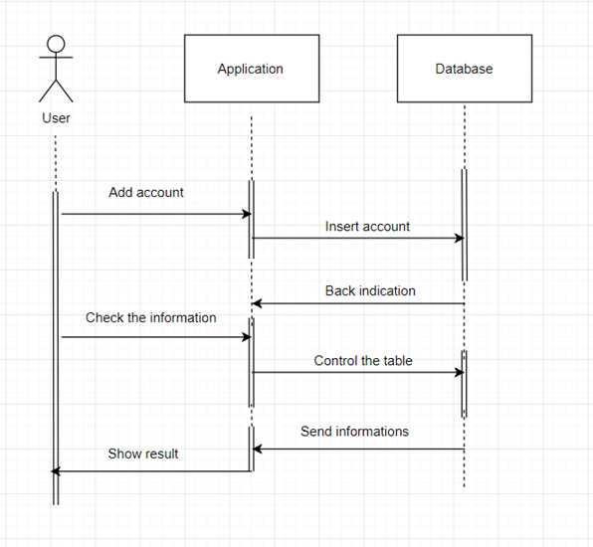

**Figure 6.2.2 - Sequence Diagram**

**6.3 - Structural Models**

**6.3.1 - Mobile Application Class Diagram**

## 

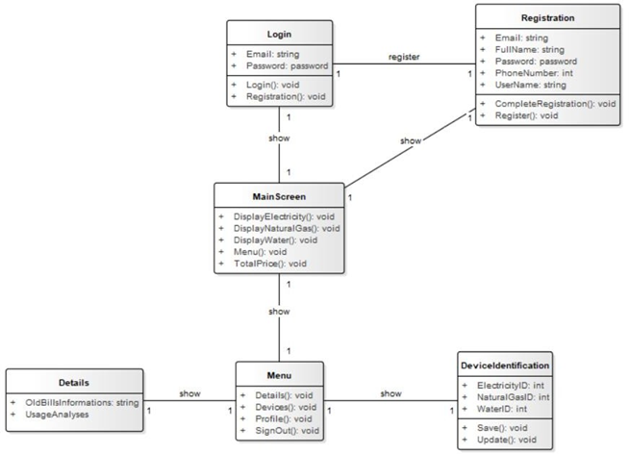

**Figure 6.3.1 - Mobile Application Class Diagram**

## 

## 

**6.4 - Behavioral Models**

**6.4.1 Activity Diagram**

**6.4.1.1 Login Activitiy Diagram**

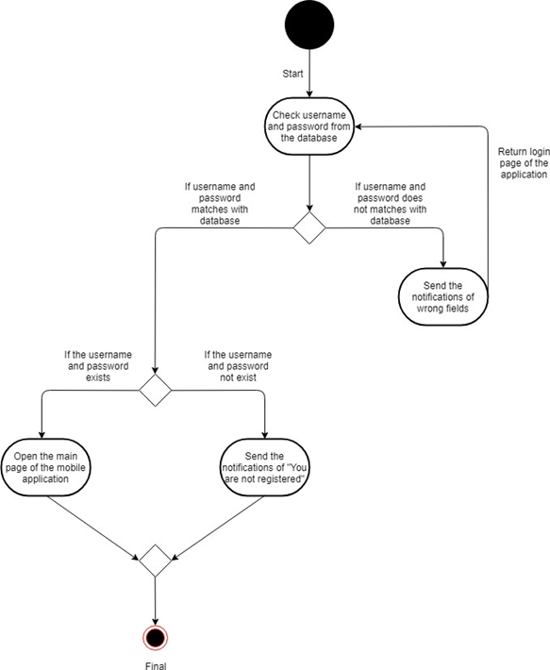

**Figure 6.4.1.1 - Login Activity Diagram**

**6.4.1.2 - Sign-up Activity Diagram**

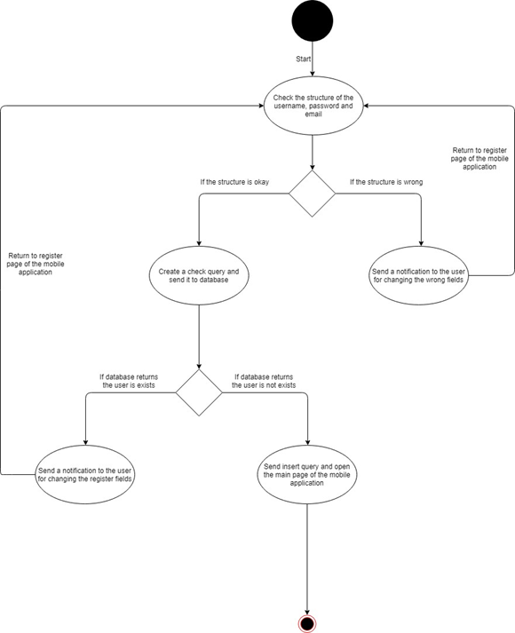

**Figure 6.4.1.2 - Sign-up Activity Diagram**

**6.4.1.3 - Exceeded Bill Activity Diagram**

## 

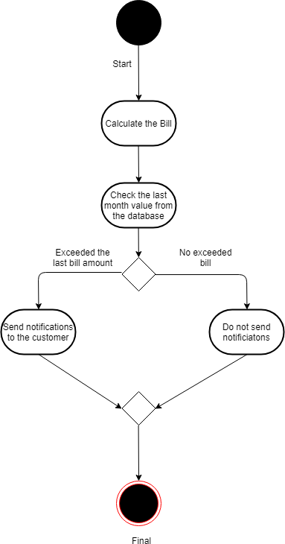

**Figure 6.4.1.3 - Exceeded Bill Activity Diagram**

**6.4.1.4 - Bill Calculation Activity Diagram**

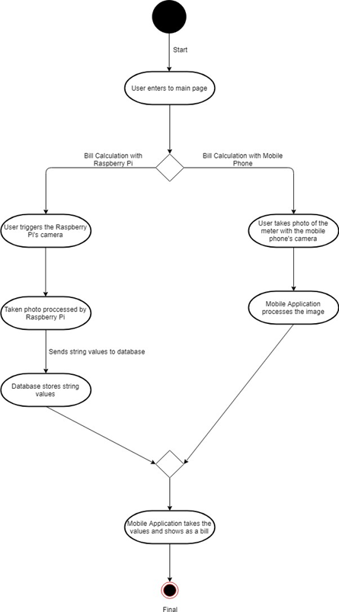

**6.5 Data Flow Diagram**

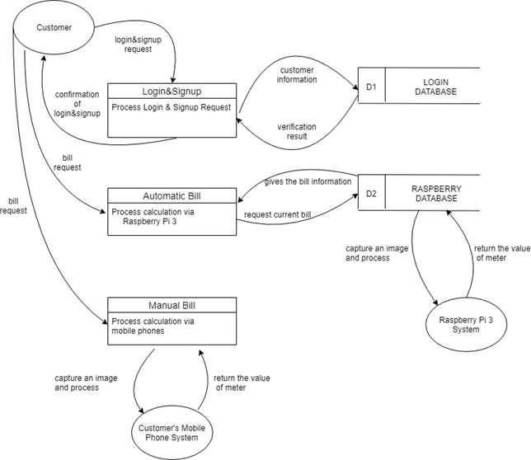

**6.6 - State Machine Diagram**

**6.6.1 - Sign-up State Machine Diagram**

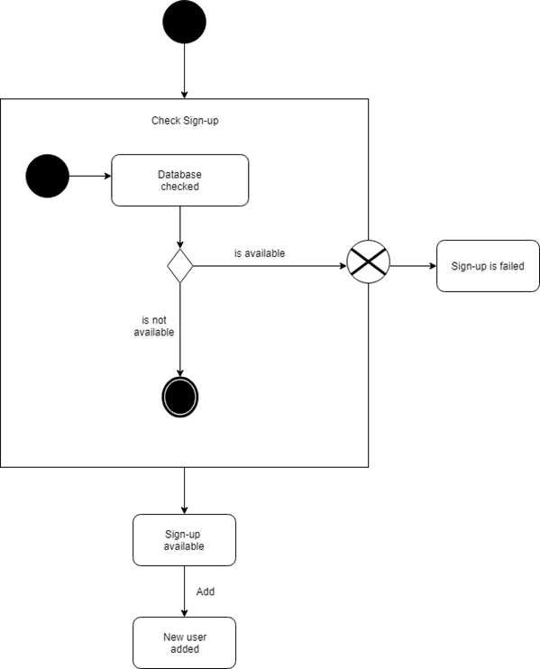

**Figure 6.6.1 - Sign-up State Machine Diagram**

**6.6.2 - Login State Machine Diagram**

## 

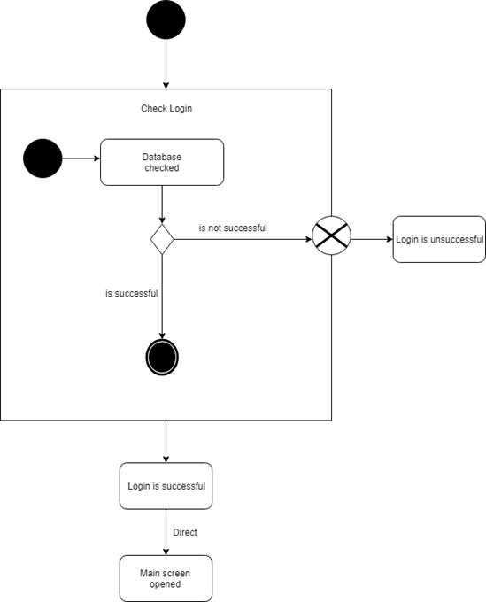

**6.6.3 - General System State Machine Diagram**

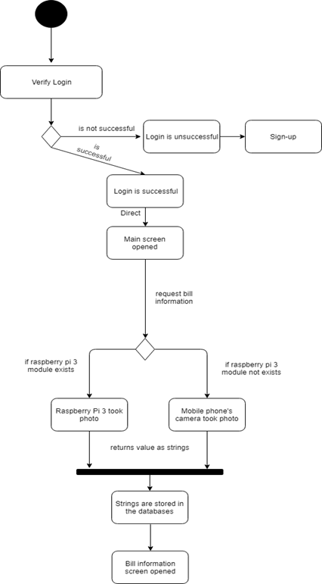

**7. Results and Discussion**

While developing this project, we have learned many things such as;

* Enviroment can be effective on qualitiy and resolution of a Picture which is taken by Raspberry Pi 3 camera module
* There are many algorithims to develop image proccessing system on Python
* Raspberry Pİ 3 device cannot connect with Firebase Database Service.
* While using Android Studio, direct connection to SQL database by using JDBC is possible, but unsecure.
* Raspberry Pi 3 device have WI-FI adapter to connect to the internet. However, Raspberry Pi 2 device needs ethernet connection.
* Firebase methods cannot work with SQL methods on Android Studio.
* While reading the values on Picture which is taken by using Raspberry Pi 3 device system, “1” and “7” can cause a problem about reading.

Otherwise, as the developer team of this project, we have faced with some kinds of problems. However, We have great resources about developing mobile application or Raspberry Pi 3 devices so, while solving the problems, we have learned new things and improve our skills.

**8. Conclusions**

As a result, as a software developer team, we have developed a project that people can get information about their electricity and water usage and bill cost momently. These two-sided project provides an opportunity that people can be aware of their expected bill costs. The main goal of our project is informing people about their usage water and electricity before at the end of the month. Moreover, by informing people about bill costs momently, conscious consumption can be provided. As a result of the working of the developer team, Killbill was published and it can be used by every household.